alpha=2

offensive=normal

1 run......

Downloading: 100%

445M/445M [00:14<00:00, 32.9MB/s]

training 1 epoch...

47.07458734512329 seconds used......

1 training finished! average train loss: 1.8249219273909545

total clf loss: 116.85031142830849 total adv loss: 83.91875475645065

evaluating...

Confusion matrix, without normalization

[[ 28 56 12]

[ 8 305 42]

[ 18 159 542]]

Normalized confusion matrix

[[0.29166667 0.58333333 0.125 ]

[0.02253521 0.85915493 0.11830986]

[0.02503477 0.22114047 0.75382476]]

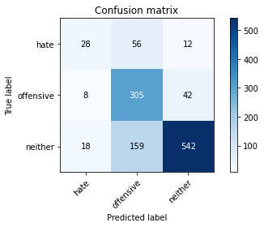

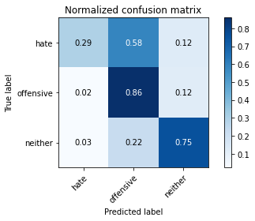

precision recall f1-score support

hate 0.52 0.29 0.37 96

offensive 0.59 0.86 0.70 355

neither 0.91 0.75 0.82 719

accuracy 0.75 1170

macro avg 0.67 0.63 0.63 1170

weighted avg 0.78 0.75 0.75 1170

average eval_loss: 0.6073389879222644, accuracy: 0.7478632478632479

training 2 epoch...

46.369412422180176 seconds used......

2 training finished! average train loss: 1.0352189403313856

total clf loss: 64.5589406862855 total adv loss: 48.46760671213269

evaluating...

Confusion matrix, without normalization

[[ 55 29 12]

[ 27 276 52]

[ 24 111 584]]

Normalized confusion matrix

[[0.57291667 0.30208333 0.125 ]

[0.07605634 0.77746479 0.14647887]

[0.03337969 0.15438108 0.81223922]]

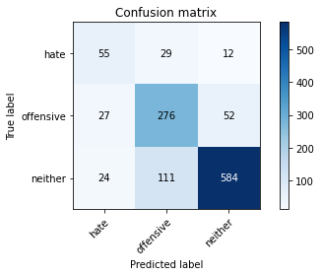

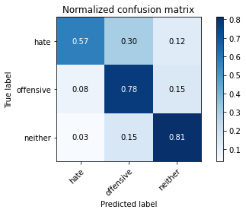

precision recall f1-score support

hate 0.52 0.57 0.54 96

offensive 0.66 0.78 0.72 355

neither 0.90 0.81 0.85 719

accuracy 0.78 1170

macro avg 0.69 0.72 0.70 1170

weighted avg 0.80 0.78 0.79 1170

average eval_loss: 0.5331080299565347, accuracy: 0.782051282051282

training 3 epoch...

46.38253164291382 seconds used......

3 training finished! average train loss: 0.45438563049985814

total clf loss: 31.53766532614827 total adv loss: 19.673246344784275

evaluating...

Confusion matrix, without normalization

[[ 43 33 20]

[ 19 277 59]

[ 22 88 609]]

Normalized confusion matrix

[[0.44791667 0.34375 0.20833333]

[0.05352113 0.78028169 0.16619718]

[0.03059805 0.12239221 0.84700974]]

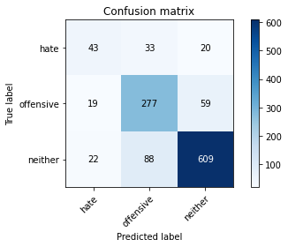

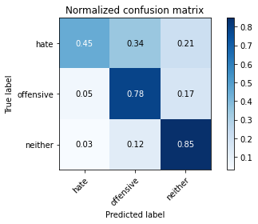

precision recall f1-score support

hate 0.51 0.45 0.48 96

offensive 0.70 0.78 0.74 355

neither 0.89 0.85 0.87 719

accuracy 0.79 1170

macro avg 0.70 0.69 0.69 1170

weighted avg 0.80 0.79 0.79 1170

average eval_loss: 0.6260679056710106, accuracy: 0.794017094017094

training 4 epoch...

46.40581297874451 seconds used......

4 training finished! average train loss: 0.2390811336107361

total clf loss: 17.009389725048095 total adv loss: 10.143633559375303

evaluating...

Confusion matrix, without normalization

[[ 53 21 22]

[ 22 267 66]

[ 23 79 617]]

Normalized confusion matrix

[[0.55208333 0.21875 0.22916667]

[0.06197183 0.75211268 0.18591549]

[0.03198887 0.10987483 0.8581363 ]]

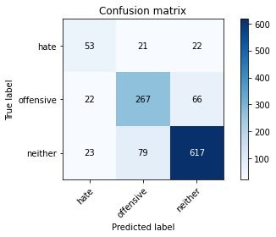

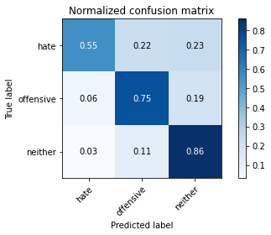

precision recall f1-score support

hate 0.54 0.55 0.55 96

offensive 0.73 0.75 0.74 355

neither 0.88 0.86 0.87 719

accuracy 0.80 1170

macro avg 0.71 0.72 0.72 1170

weighted avg 0.80 0.80 0.80 1170

average eval_loss: 0.7413422110159014, accuracy: 0.8008547008547009

training 5 epoch...

46.23741102218628 seconds used......

5 training finished! average train loss: 0.12171029215469623

total clf loss: 9.545366262085736 total adv loss: 4.72071969161334

evaluating...

Confusion matrix, without normalization

[[ 60 32 4]

[ 27 303 25]

[ 60 169 490]]

Normalized confusion matrix

[[0.625 0.33333333 0.04166667]

[0.07605634 0.85352113 0.07042254]

[0.08344924 0.23504868 0.68150209]]

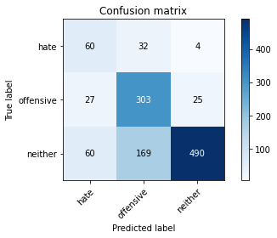

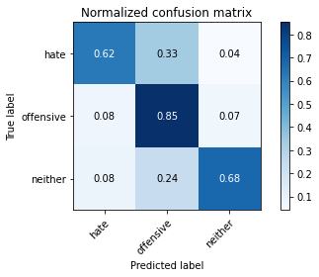

precision recall f1-score support

hate 0.41 0.62 0.49 96

offensive 0.60 0.85 0.71 355

neither 0.94 0.68 0.79 719

accuracy 0.73 1170

macro avg 0.65 0.72 0.66 1170

weighted avg 0.80 0.73 0.74 1170

average eval_loss: 1.1045965463933298, accuracy: 0.729059829059829

training 6 epoch...

46.39591145515442 seconds used......

6 training finished! average train loss: 0.14658426767877805

total clf loss: 9.523382440092973 total adv loss: 6.671881693197065

evaluating...

Confusion matrix, without normalization

[[ 39 39 18]

[ 10 292 53]

[ 12 111 596]]

Normalized confusion matrix

[[0.40625 0.40625 0.1875 ]

[0.02816901 0.82253521 0.14929577]

[0.01668985 0.15438108 0.82892907]]

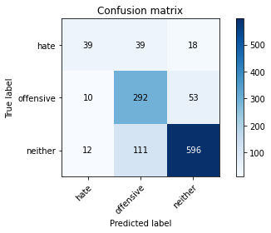

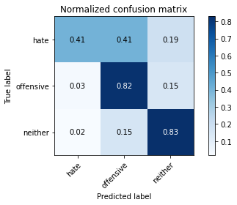

precision recall f1-score support

hate 0.64 0.41 0.50 96

offensive 0.66 0.82 0.73 355

neither 0.89 0.83 0.86 719

accuracy 0.79 1170

macro avg 0.73 0.69 0.70 1170

weighted avg 0.80 0.79 0.79 1170

average eval_loss: 0.8187368702522274, accuracy: 0.7923076923076923

training 7 epoch...

46.35987901687622 seconds used......

7 training finished! average train loss: 0.09316783373464997

total clf loss: 6.005070263752714 total adv loss: 4.264555906469468

evaluating...

Confusion matrix, without normalization

[[ 54 30 12]

[ 25 288 42]

[ 30 112 577]]

Normalized confusion matrix

[[0.5625 0.3125 0.125 ]

[0.07042254 0.81126761 0.11830986]

[0.04172462 0.15577191 0.80250348]]

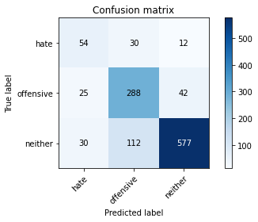

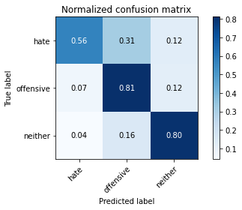

precision recall f1-score support

hate 0.50 0.56 0.53 96

offensive 0.67 0.81 0.73 355

neither 0.91 0.80 0.85 719

accuracy 0.79 1170

macro avg 0.69 0.73 0.71 1170

weighted avg 0.81 0.79 0.79 1170

average eval_loss: 0.9502329204420922, accuracy: 0.7854700854700855

training 8 epoch...

46.27072834968567 seconds used......

8 training finished! average train loss: 0.07343726274587262

total clf loss: 4.757165259274188 total adv loss: 3.3495239207404666

evaluating...

Confusion matrix, without normalization

[[ 63 24 9]

[ 33 276 46]

[ 38 111 570]]

Normalized confusion matrix

[[0.65625 0.25 0.09375 ]

[0.09295775 0.77746479 0.12957746]

[0.05285118 0.15438108 0.79276773]]

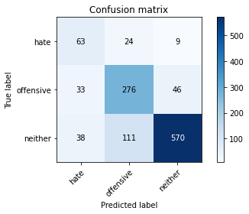

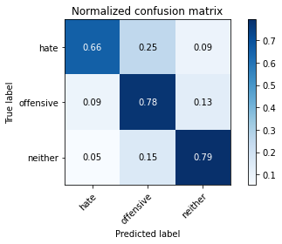

precision recall f1-score support

hate 0.47 0.66 0.55 96

offensive 0.67 0.78 0.72 355

neither 0.91 0.79 0.85 719

accuracy 0.78 1170

macro avg 0.68 0.74 0.71 1170

weighted avg 0.80 0.78 0.78 1170

average eval_loss: 0.9966250872002693, accuracy: 0.7769230769230769

training 9 epoch...

46.41607189178467 seconds used......

9 training finished! average train loss: 0.09267641504769787

total clf loss: 5.294987289234996 total adv loss: 4.581266728922856

evaluating...

Confusion matrix, without normalization

[[ 59 21 16]

[ 26 248 81]

[ 25 51 643]]

Normalized confusion matrix

[[0.61458333 0.21875 0.16666667]

[0.07323944 0.69859155 0.22816901]

[0.03477051 0.07093185 0.89429764]]

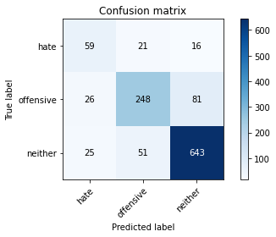

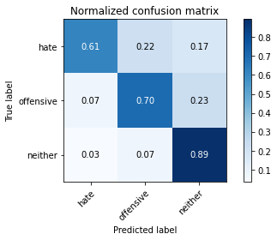

precision recall f1-score support

hate 0.54 0.61 0.57 96

offensive 0.78 0.70 0.73 355

neither 0.87 0.89 0.88 719

accuracy 0.81 1170

macro avg 0.73 0.74 0.73 1170

weighted avg 0.81 0.81 0.81 1170

average eval_loss: 0.8360514562711183, accuracy: 0.811965811965812

training 10 epoch...

46.31888437271118 seconds used......

10 training finished! average train loss: 0.05137965201496487

total clf loss: 3.2738503863220103 total adv loss: 2.3706876903033844

evaluating...

Confusion matrix, without normalization

[[ 66 21 9]

[ 32 276 47]

[ 47 100 572]]

Normalized confusion matrix

[[0.6875 0.21875 0.09375 ]

[0.09014085 0.77746479 0.13239437]

[0.06536857 0.13908206 0.79554937]]

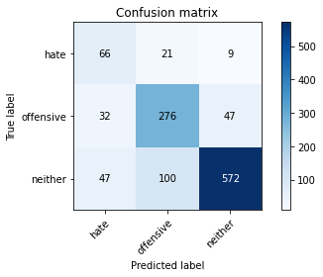

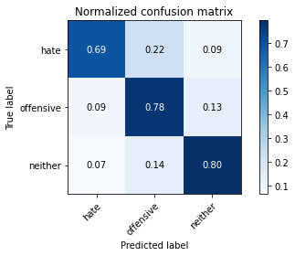

precision recall f1-score support

hate 0.46 0.69 0.55 96

offensive 0.70 0.78 0.73 355

neither 0.91 0.80 0.85 719

accuracy 0.78 1170

macro avg 0.69 0.75 0.71 1170

weighted avg 0.81 0.78 0.79 1170

average eval_loss: 0.9965007664414786, accuracy: 0.7811965811965812

2 run......

training 1 epoch...

46.33760142326355 seconds used......

1 training finished! average train loss: 1.8080700960678933

total clf loss: 115.02791878581047 total adv loss: 83.51550783216953

evaluating...

Confusion matrix, without normalization

[[ 10 69 17]

[ 1 299 55]

[ 0 130 589]]

Normalized confusion matrix

[[0.10416667 0.71875 0.17708333]

[0.0028169 0.84225352 0.15492958]

[0. 0.18080668 0.81919332]]

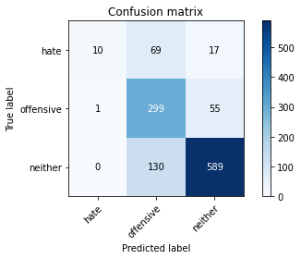

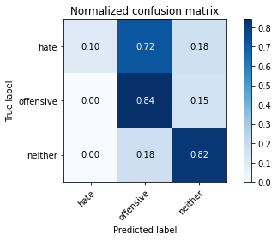

precision recall f1-score support

hate 0.91 0.10 0.19 96

offensive 0.60 0.84 0.70 355

neither 0.89 0.82 0.85 719

accuracy 0.77 1170

macro avg 0.80 0.59 0.58 1170

weighted avg 0.80 0.77 0.75 1170

average eval_loss: 0.5426495883424404, accuracy: 0.7675213675213676

training 2 epoch...

46.26708674430847 seconds used......

2 training finished! average train loss: 1.0235547419541922

total clf loss: 64.99149168282747 total adv loss: 47.34152366220951

evaluating...

Confusion matrix, without normalization

[[ 47 32 17]

[ 10 276 69]

[ 20 89 610]]

Normalized confusion matrix

[[0.48958333 0.33333333 0.17708333]

[0.02816901 0.77746479 0.1943662 ]

[0.02781641 0.12378303 0.84840056]]

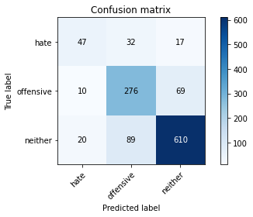

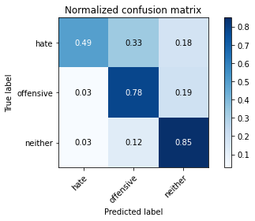

precision recall f1-score support

hate 0.61 0.49 0.54 96

offensive 0.70 0.78 0.73 355

neither 0.88 0.85 0.86 719

accuracy 0.80 1170

macro avg 0.73 0.71 0.71 1170

weighted avg 0.80 0.80 0.80 1170

average eval_loss: 0.532826608015319, accuracy: 0.7974358974358975

training 3 epoch...

46.377511739730835 seconds used......

3 training finished! average train loss: 0.4996938700190721

total clf loss: 34.04166926443577 total adv loss: 21.95528712309897

evaluating...

Confusion matrix, without normalization

[[ 57 25 14]

[ 31 272 52]

[ 24 104 591]]

Normalized confusion matrix

[[0.59375 0.26041667 0.14583333]

[0.08732394 0.76619718 0.14647887]

[0.03337969 0.14464534 0.82197497]]

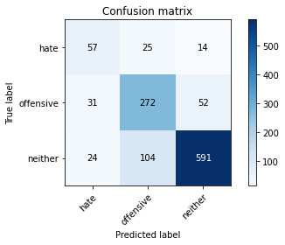

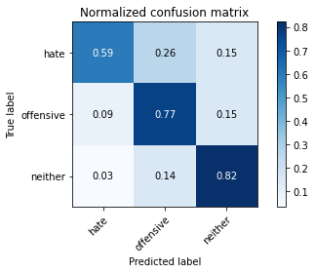

precision recall f1-score support

hate 0.51 0.59 0.55 96

offensive 0.68 0.77 0.72 355

neither 0.90 0.82 0.86 719

accuracy 0.79 1170

macro avg 0.70 0.73 0.71 1170

weighted avg 0.80 0.79 0.79 1170

average eval_loss: 0.6390540325793169, accuracy: 0.7863247863247863

training 4 epoch...

46.314199447631836 seconds used......

4 training finished! average train loss: 0.27375011791128856

total clf loss: 19.308102711103857 total adv loss: 11.698457905498799

evaluating...

Confusion matrix, without normalization

[[ 43 39 14]

[ 12 288 55]

[ 17 98 604]]

Normalized confusion matrix

[[0.44791667 0.40625 0.14583333]

[0.03380282 0.81126761 0.15492958]

[0.02364395 0.13630042 0.84005563]]

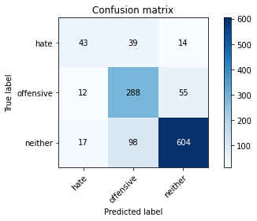

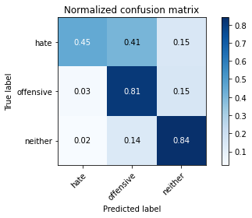

precision recall f1-score support

hate 0.60 0.45 0.51 96

offensive 0.68 0.81 0.74 355

neither 0.90 0.84 0.87 719

accuracy 0.80 1170

macro avg 0.72 0.70 0.71 1170

weighted avg 0.81 0.80 0.80 1170

average eval_loss: 0.6837098068731317, accuracy: 0.7991452991452992

training 5 epoch...

46.311793088912964 seconds used......

5 training finished! average train loss: 0.13740376820369887

total clf loss: 10.43088281294331 total adv loss: 5.502052579104202

evaluating...

Confusion matrix, without normalization

[[ 56 32 8]

[ 31 279 45]

[ 32 108 579]]

Normalized confusion matrix

[[0.58333333 0.33333333 0.08333333]

[0.08732394 0.78591549 0.12676056]

[0.04450626 0.15020862 0.80528512]]

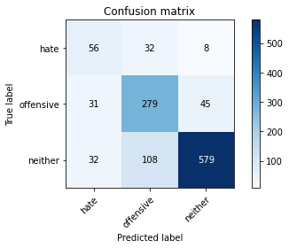

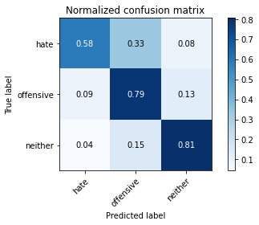

precision recall f1-score support

hate 0.47 0.58 0.52 96

offensive 0.67 0.79 0.72 355

neither 0.92 0.81 0.86 719

accuracy 0.78 1170

macro avg 0.68 0.72 0.70 1170

weighted avg 0.80 0.78 0.79 1170

average eval_loss: 0.9102400224340164, accuracy: 0.7811965811965812

training 6 epoch...

46.46186804771423 seconds used......

6 training finished! average train loss: 0.13375239498698369

total clf loss: 8.886528946924955 total adv loss: 5.989422274069511

evaluating...

Confusion matrix, without normalization

[[ 62 26 8]

[ 29 283 43]

[ 37 99 583]]

Normalized confusion matrix

[[0.64583333 0.27083333 0.08333333]

[0.08169014 0.7971831 0.12112676]

[0.05146036 0.13769124 0.8108484 ]]

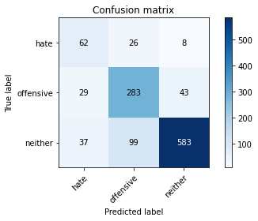

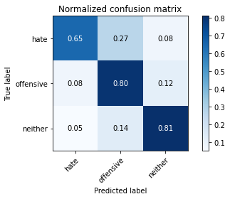

precision recall f1-score support

hate 0.48 0.65 0.55 96

offensive 0.69 0.80 0.74 355

neither 0.92 0.81 0.86 719

accuracy 0.79 1170

macro avg 0.70 0.75 0.72 1170

weighted avg 0.82 0.79 0.80 1170

average eval_loss: 0.8471638268585933, accuracy: 0.7931623931623931

training 7 epoch...

46.2988486289978 seconds used......

7 training finished! average train loss: 0.14048044175023022

total clf loss: 8.699093976290897 total adv loss: 6.607927467026457

evaluating...

Confusion matrix, without normalization

[[ 71 12 13]

[ 52 248 55]

[ 47 63 609]]

Normalized confusion matrix

[[0.73958333 0.125 0.13541667]

[0.14647887 0.69859155 0.15492958]

[0.06536857 0.0876217 0.84700974]]

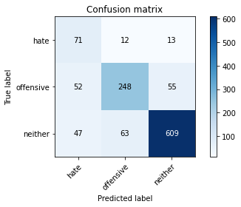

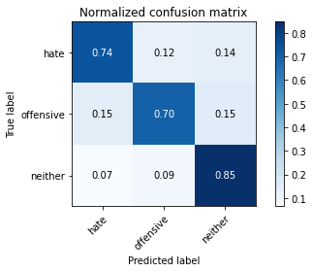

precision recall f1-score support

hate 0.42 0.74 0.53 96

offensive 0.77 0.70 0.73 355

neither 0.90 0.85 0.87 719

accuracy 0.79 1170

macro avg 0.70 0.76 0.71 1170

weighted avg 0.82 0.79 0.80 1170

average eval_loss: 0.9598588865818614, accuracy: 0.7931623931623931

training 8 epoch...

46.345908641815186 seconds used......

8 training finished! average train loss: 0.10709366877264796

total clf loss: 6.518005103804171 total adv loss: 5.094303661651793

evaluating...

Confusion matrix, without normalization

[[ 60 20 16]

[ 28 259 68]

[ 22 55 642]]

Normalized confusion matrix

[[0.625 0.20833333 0.16666667]

[0.07887324 0.72957746 0.1915493 ]

[0.03059805 0.07649513 0.89290682]]

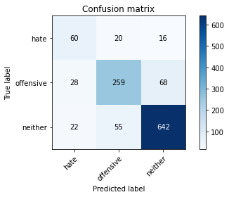

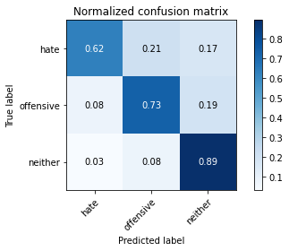

precision recall f1-score support

hate 0.55 0.62 0.58 96

offensive 0.78 0.73 0.75 355

neither 0.88 0.89 0.89 719

accuracy 0.82 1170

macro avg 0.74 0.75 0.74 1170

weighted avg 0.82 0.82 0.82 1170

average eval_loss: 0.7808433066800995, accuracy: 0.8213675213675213

training 9 epoch...

46.29733467102051 seconds used......

9 training finished! average train loss: 0.0468357575483447

total clf loss: 2.98308161937166 total adv loss: 2.1616482847948646

evaluating...

Confusion matrix, without normalization

[[ 66 22 8]

[ 30 275 50]

[ 27 84 608]]

Normalized confusion matrix

[[0.6875 0.22916667 0.08333333]

[0.08450704 0.77464789 0.14084507]

[0.03755216 0.11682893 0.84561892]]

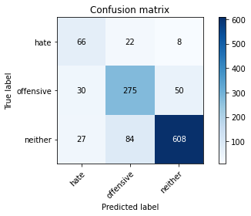

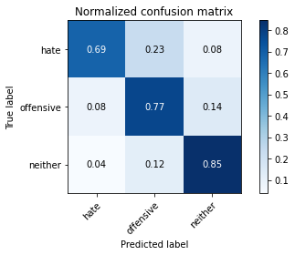

precision recall f1-score support

hate 0.54 0.69 0.60 96

offensive 0.72 0.77 0.75 355

neither 0.91 0.85 0.88 719

accuracy 0.81 1170

macro avg 0.72 0.77 0.74 1170

weighted avg 0.82 0.81 0.82 1170

average eval_loss: 0.9037950700938197, accuracy: 0.8111111111111111

training 10 epoch...

46.250760078430176 seconds used......

10 training finished! average train loss: 0.036385609203791365

total clf loss: 2.1635763068916276 total adv loss: 1.7562893742324377

evaluating...

Confusion matrix, without normalization

[[ 43 45 8]

[ 14 306 35]

[ 23 143 553]]

Normalized confusion matrix

[[0.44791667 0.46875 0.08333333]

[0.03943662 0.86197183 0.09859155]

[0.03198887 0.19888734 0.76912378]]

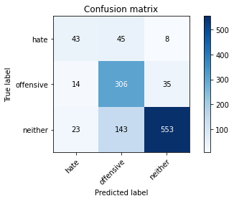

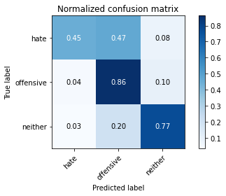

precision recall f1-score support

hate 0.54 0.45 0.49 96

offensive 0.62 0.86 0.72 355

neither 0.93 0.77 0.84 719

accuracy 0.77 1170

macro avg 0.69 0.69 0.68 1170

weighted avg 0.80 0.77 0.78 1170

average eval_loss: 1.1621697098805994, accuracy: 0.770940170940171

3 run......

training 1 epoch...

46.372211933135986 seconds used......

1 training finished! average train loss: 1.8432343972799106

total clf loss: 118.18850564956665 total adv loss: 84.67803034186363

evaluating...

Confusion matrix, without normalization

[[ 54 28 14]

[ 42 272 41]

[ 32 129 558]]

Normalized confusion matrix

[[0.5625 0.29166667 0.14583333]

[0.11830986 0.76619718 0.11549296]

[0.04450626 0.17941586 0.77607789]]

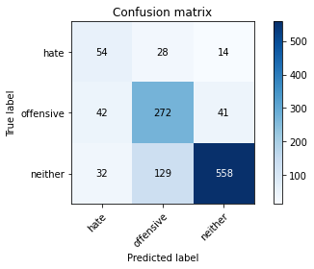

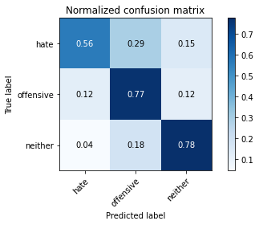

precision recall f1-score support

hate 0.42 0.56 0.48 96

offensive 0.63 0.77 0.69 355

neither 0.91 0.78 0.84 719

accuracy 0.76 1170

macro avg 0.66 0.70 0.67 1170

weighted avg 0.79 0.76 0.76 1170

average eval_loss: 0.605494844206309, accuracy: 0.7555555555555555

training 2 epoch...

46.49401259422302 seconds used......

2 training finished! average train loss: 1.1396375923202589

total clf loss: 70.90861293673515 total adv loss: 53.437425434589386

evaluating...

Confusion matrix, without normalization

[[ 38 43 15]

[ 10 289 56]

[ 16 90 613]]

Normalized confusion matrix

[[0.39583333 0.44791667 0.15625 ]

[0.02816901 0.81408451 0.15774648]

[0.02225313 0.12517385 0.85257302]]

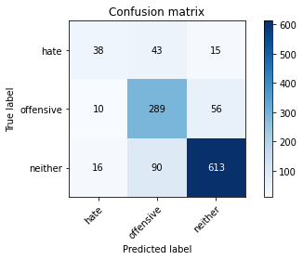

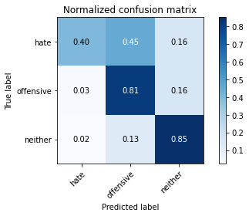

precision recall f1-score support

hate 0.59 0.40 0.48 96

offensive 0.68 0.81 0.74 355

neither 0.90 0.85 0.87 719

accuracy 0.80 1170

macro avg 0.72 0.69 0.70 1170

weighted avg 0.81 0.80 0.80 1170

average eval_loss: 0.49716585369433386, accuracy: 0.8034188034188035

training 3 epoch...

46.368961572647095 seconds used......

3 training finished! average train loss: 0.552816910812488

total clf loss: 37.11176220327616 total adv loss: 24.56383795198053

evaluating...

Confusion matrix, without normalization

[[ 48 29 19]

[ 26 271 58]

[ 32 84 603]]

Normalized confusion matrix

[[0.5 0.30208333 0.19791667]

[0.07323944 0.76338028 0.16338028]

[0.04450626 0.11682893 0.83866481]]

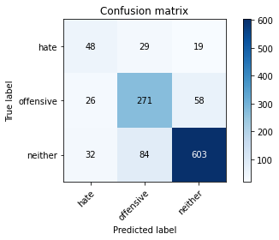

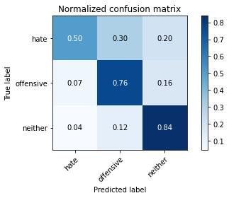

precision recall f1-score support

hate 0.45 0.50 0.48 96

offensive 0.71 0.76 0.73 355

neither 0.89 0.84 0.86 719

accuracy 0.79 1170

macro avg 0.68 0.70 0.69 1170

weighted avg 0.80 0.79 0.79 1170

average eval_loss: 0.6311408604605723, accuracy: 0.788034188034188

training 4 epoch...

46.46183800697327 seconds used......

4 training finished! average train loss: 0.3002315407786041

total clf loss: 22.012606270145625 total adv loss: 12.411756875109859

evaluating...

Confusion matrix, without normalization

[[ 49 31 16]

[ 24 268 63]

[ 24 92 603]]

Normalized confusion matrix

[[0.51041667 0.32291667 0.16666667]

[0.06760563 0.75492958 0.17746479]

[0.03337969 0.12795549 0.83866481]]

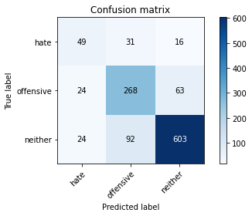

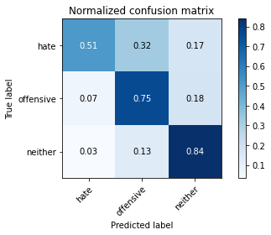

precision recall f1-score support

hate 0.51 0.51 0.51 96

offensive 0.69 0.75 0.72 355

neither 0.88 0.84 0.86 719

accuracy 0.79 1170

macro avg 0.69 0.70 0.70 1170

weighted avg 0.79 0.79 0.79 1170

average eval_loss: 0.6817202232778072, accuracy: 0.7863247863247863

training 5 epoch...

46.36151909828186 seconds used......

5 training finished! average train loss: 0.16946116690404522

total clf loss: 13.549547339323908 total adv loss: 6.443197379587218

evaluating...

Confusion matrix, without normalization

[[ 61 30 5]

[ 34 290 31]

[ 47 139 533]]

Normalized confusion matrix

[[0.63541667 0.3125 0.05208333]

[0.09577465 0.81690141 0.08732394]

[0.06536857 0.19332406 0.74130737]]

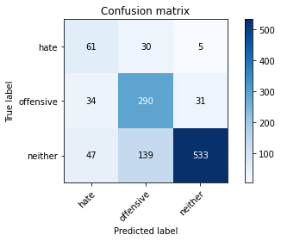

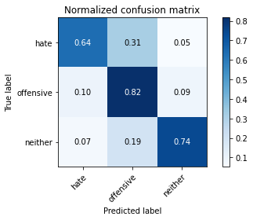

precision recall f1-score support

hate 0.43 0.64 0.51 96

offensive 0.63 0.82 0.71 355

neither 0.94 0.74 0.83 719

accuracy 0.76 1170

macro avg 0.67 0.73 0.68 1170

weighted avg 0.80 0.76 0.77 1170

average eval_loss: 0.9431182231312081, accuracy: 0.7555555555555555

training 6 epoch...

46.32203245162964 seconds used......

6 training finished! average train loss: 0.10091668610365535

total clf loss: 7.004396735923365 total adv loss: 4.369303144183505

evaluating...

Confusion matrix, without normalization

[[ 62 28 6]

[ 38 278 39]

[ 54 106 559]]

Normalized confusion matrix

[[0.64583333 0.29166667 0.0625 ]

[0.10704225 0.78309859 0.10985915]

[0.07510431 0.14742698 0.77746871]]

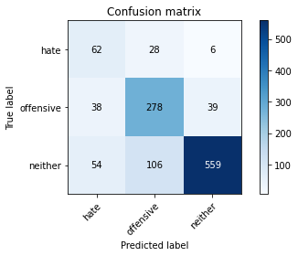

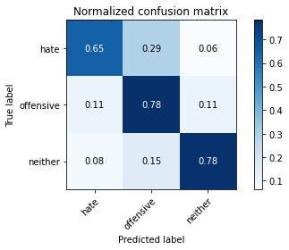

precision recall f1-score support

hate 0.40 0.65 0.50 96

offensive 0.67 0.78 0.72 355

neither 0.93 0.78 0.85 719

accuracy 0.77 1170

macro avg 0.67 0.74 0.69 1170

weighted avg 0.81 0.77 0.78 1170

average eval_loss: 0.9112895872696476, accuracy: 0.7683760683760684

training 7 epoch...

46.39276623725891 seconds used......

7 training finished! average train loss: 0.11347573966934131

total clf loss: 6.860783827025443 total adv loss: 5.420715787273366

evaluating...

Confusion matrix, without normalization

[[ 63 23 10]

[ 37 259 59]

[ 45 69 605]]

Normalized confusion matrix

[[0.65625 0.23958333 0.10416667]

[0.10422535 0.72957746 0.16619718]

[0.06258693 0.09596662 0.84144645]]

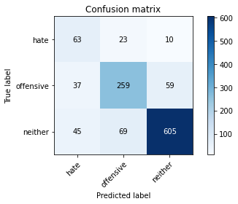

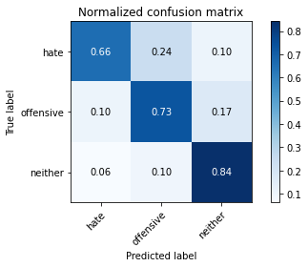

precision recall f1-score support

hate 0.43 0.66 0.52 96

offensive 0.74 0.73 0.73 355

neither 0.90 0.84 0.87 719

accuracy 0.79 1170

macro avg 0.69 0.74 0.71 1170

weighted avg 0.81 0.79 0.80 1170

average eval_loss: 0.8608065722983772, accuracy: 0.7923076923076923

training 8 epoch...

46.457003116607666 seconds used......

8 training finished! average train loss: 0.06456504069949286

total clf loss: 4.371757618151605 total adv loss: 2.8501943535666214

evaluating...

Confusion matrix, without normalization

[[ 57 26 13]

[ 37 249 69]

[ 37 62 620]]

Normalized confusion matrix

[[0.59375 0.27083333 0.13541667]

[0.10422535 0.70140845 0.1943662 ]

[0.05146036 0.08623088 0.86230876]]

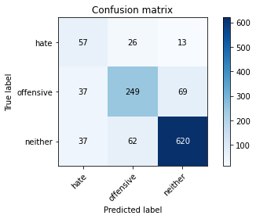

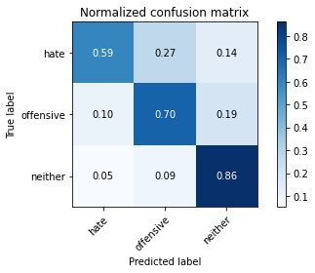

precision recall f1-score support

hate 0.44 0.59 0.50 96

offensive 0.74 0.70 0.72 355

neither 0.88 0.86 0.87 719

accuracy 0.79 1170

macro avg 0.69 0.72 0.70 1170

weighted avg 0.80 0.79 0.80 1170

average eval_loss: 0.8478920120051352, accuracy: 0.7914529914529914

training 9 epoch...

46.27459502220154 seconds used......

9 training finished! average train loss: 0.08426149638081626

total clf loss: 4.641320856317179 total adv loss: 4.251736348420309

evaluating...

Confusion matrix, without normalization

[[ 44 32 20]

[ 23 262 70]

[ 28 65 626]]

Normalized confusion matrix

[[0.45833333 0.33333333 0.20833333]

[0.06478873 0.73802817 0.1971831 ]

[0.03894298 0.09040334 0.87065369]]

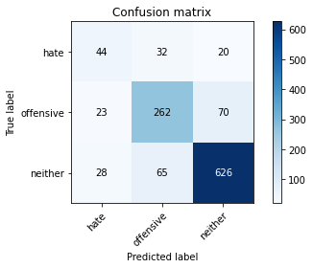

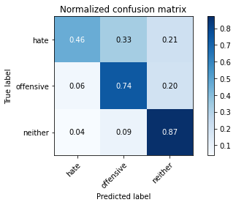

precision recall f1-score support

hate 0.46 0.46 0.46 96

offensive 0.73 0.74 0.73 355

neither 0.87 0.87 0.87 719

accuracy 0.80 1170

macro avg 0.69 0.69 0.69 1170

weighted avg 0.80 0.80 0.80 1170

average eval_loss: 0.9261084756166753, accuracy: 0.7965811965811965

training 10 epoch...

46.48315477371216 seconds used......

10 training finished! average train loss: 0.07065274513390762

total clf loss: 4.880568419583142 total adv loss: 3.0706298834757035

evaluating...

Confusion matrix, without normalization

[[ 63 27 6]

[ 37 277 41]

[ 56 101 562]]

Normalized confusion matrix

[[0.65625 0.28125 0.0625 ]

[0.10422535 0.78028169 0.11549296]

[0.07788595 0.14047288 0.78164117]]

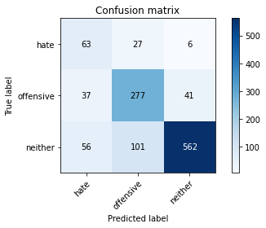

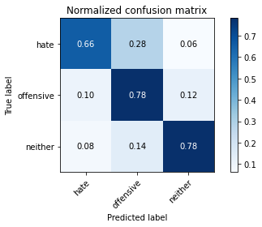

precision recall f1-score support

hate 0.40 0.66 0.50 96

offensive 0.68 0.78 0.73 355

neither 0.92 0.78 0.85 719

accuracy 0.77 1170

macro avg 0.67 0.74 0.69 1170

weighted avg 0.81 0.77 0.78 1170

average eval_loss: 1.01955386937075, accuracy: 0.770940170940171

4 run......

training 1 epoch...

46.31843304634094 seconds used......

1 training finished! average train loss: 1.8653305501509936

total clf loss: 119.45455586910248 total adv loss: 85.76850500702858

evaluating...

Confusion matrix, without normalization

[[ 41 42 13]

[ 11 290 54]

[ 11 123 585]]

Normalized confusion matrix

[[0.42708333 0.4375 0.13541667]

[0.03098592 0.81690141 0.15211268]

[0.01529903 0.17107093 0.81363004]]

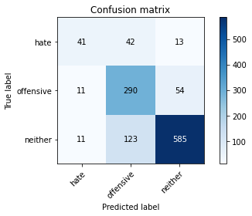

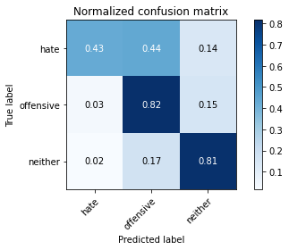

precision recall f1-score support

hate 0.65 0.43 0.52 96

offensive 0.64 0.82 0.72 355

neither 0.90 0.81 0.85 719

accuracy 0.78 1170

macro avg 0.73 0.69 0.70 1170

weighted avg 0.80 0.78 0.78 1170

average eval_loss: 0.5347351517717717, accuracy: 0.7829059829059829

training 2 epoch...

46.363874197006226 seconds used......

2 training finished! average train loss: 1.099476901957622

total clf loss: 69.08471246063709 total adv loss: 51.21684217453003

evaluating...

Confusion matrix, without normalization

[[ 57 33 6]

[ 21 305 29]

[ 31 143 545]]

Normalized confusion matrix

[[0.59375 0.34375 0.0625 ]

[0.05915493 0.85915493 0.08169014]

[0.04311544 0.19888734 0.75799722]]

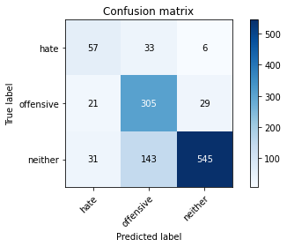

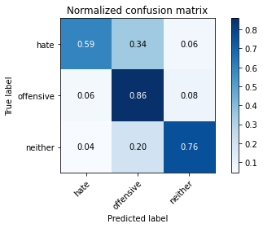

precision recall f1-score support

hate 0.52 0.59 0.56 96

offensive 0.63 0.86 0.73 355

neither 0.94 0.76 0.84 719

accuracy 0.78 1170

macro avg 0.70 0.74 0.71 1170

weighted avg 0.81 0.78 0.78 1170

average eval_loss: 0.597410952135668, accuracy: 0.7752136752136752

training 3 epoch...

46.374186754226685 seconds used......

3 training finished! average train loss: 0.5013995589927221

total clf loss: 33.7559928111732 total adv loss: 22.231169344391674

evaluating...

Confusion matrix, without normalization

[[ 41 38 17]

[ 10 282 63]

[ 8 91 620]]

Normalized confusion matrix

[[0.42708333 0.39583333 0.17708333]

[0.02816901 0.7943662 0.17746479]

[0.01112656 0.12656467 0.86230876]]

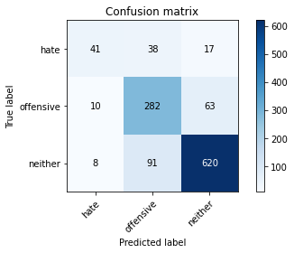

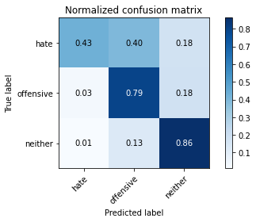

precision recall f1-score support

hate 0.69 0.43 0.53 96

offensive 0.69 0.79 0.74 355

neither 0.89 0.86 0.87 719

accuracy 0.81 1170

macro avg 0.76 0.69 0.71 1170

weighted avg 0.81 0.81 0.80 1170

average eval_loss: 0.6083037787574833, accuracy: 0.805982905982906

training 4 epoch...

46.43185114860535 seconds used......

4 training finished! average train loss: 0.25851615970858777

total clf loss: 18.5494198333472 total adv loss: 10.889550626045093

evaluating...

Confusion matrix, without normalization

[[ 49 30 17]

[ 26 262 67]

[ 21 81 617]]

Normalized confusion matrix

[[0.51041667 0.3125 0.17708333]

[0.07323944 0.73802817 0.18873239]

[0.02920723 0.11265647 0.8581363 ]]

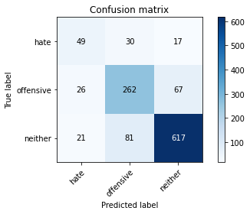

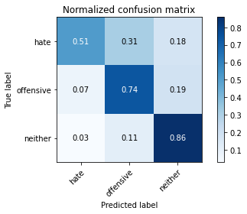

precision recall f1-score support

hate 0.51 0.51 0.51 96

offensive 0.70 0.74 0.72 355

neither 0.88 0.86 0.87 719

accuracy 0.79 1170

macro avg 0.70 0.70 0.70 1170

weighted avg 0.80 0.79 0.79 1170

average eval_loss: 0.7293316037473032, accuracy: 0.7931623931623931

training 5 epoch...

46.465537309646606 seconds used......

5 training finished! average train loss: 0.18493752724204499

total clf loss: 13.323873301967978 total adv loss: 7.763190469588153

evaluating...

Confusion matrix, without normalization

[[ 54 31 11]

[ 28 270 57]

[ 40 101 578]]

Normalized confusion matrix

[[0.5625 0.32291667 0.11458333]

[0.07887324 0.76056338 0.16056338]

[0.05563282 0.14047288 0.8038943 ]]

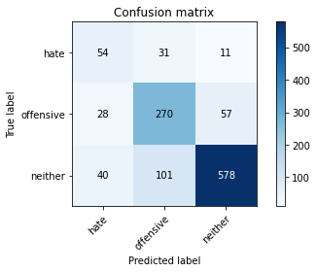

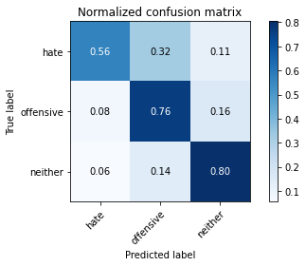

precision recall f1-score support

hate 0.44 0.56 0.50 96

offensive 0.67 0.76 0.71 355

neither 0.89 0.80 0.85 719

accuracy 0.77 1170

macro avg 0.67 0.71 0.69 1170

weighted avg 0.79 0.77 0.78 1170

average eval_loss: 0.7568639424645295, accuracy: 0.770940170940171

training 6 epoch...

46.7053427696228 seconds used......

6 training finished! average train loss: 0.1286427456742296

total clf loss: 8.652681244770065 total adv loss: 5.70779351843521

evaluating...

Confusion matrix, without normalization

[[ 62 31 3]

[ 21 306 28]

[ 50 189 480]]

Normalized confusion matrix

[[0.64583333 0.32291667 0.03125 ]

[0.05915493 0.86197183 0.07887324]

[0.06954103 0.26286509 0.66759388]]

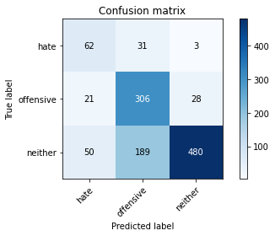

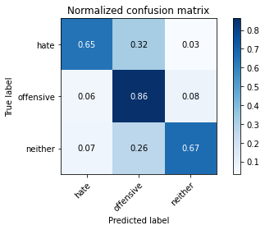

precision recall f1-score support

hate 0.47 0.65 0.54 96

offensive 0.58 0.86 0.69 355

neither 0.94 0.67 0.78 719

accuracy 0.72 1170

macro avg 0.66 0.73 0.67 1170

weighted avg 0.79 0.72 0.73 1170

average eval_loss: 1.1081360437102237, accuracy: 0.7247863247863248

training 7 epoch...

46.375118255615234 seconds used......

7 training finished! average train loss: 0.07836547041332755

total clf loss: 5.7284199794521555 total adv loss: 3.2482967299147276

evaluating...

Confusion matrix, without normalization

[[ 66 18 12]

[ 34 270 51]

[ 32 86 601]]

Normalized confusion matrix

[[0.6875 0.1875 0.125 ]

[0.09577465 0.76056338 0.14366197]

[0.04450626 0.11961057 0.83588317]]

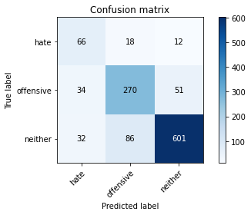

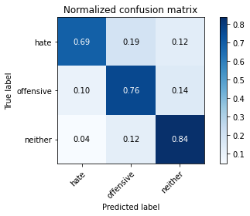

precision recall f1-score support

hate 0.50 0.69 0.58 96

offensive 0.72 0.76 0.74 355

neither 0.91 0.84 0.87 719

accuracy 0.80 1170

macro avg 0.71 0.76 0.73 1170

weighted avg 0.82 0.80 0.81 1170

average eval_loss: 0.8650784809458054, accuracy: 0.8008547008547009

training 8 epoch...

46.43793725967407 seconds used......

8 training finished! average train loss: 0.08770715523935042

total clf loss: 5.213109985808842 total adv loss: 4.23460315732882

evaluating...

Confusion matrix, without normalization

[[ 66 16 14]

[ 40 263 52]

[ 44 86 589]]

Normalized confusion matrix

[[0.6875 0.16666667 0.14583333]

[0.11267606 0.74084507 0.14647887]

[0.06119611 0.11961057 0.81919332]]

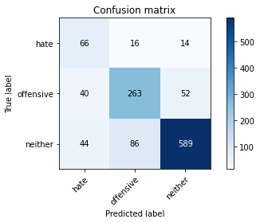

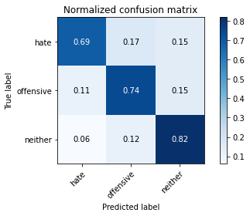

precision recall f1-score support

hate 0.44 0.69 0.54 96

offensive 0.72 0.74 0.73 355

neither 0.90 0.82 0.86 719

accuracy 0.78 1170

macro avg 0.69 0.75 0.71 1170

weighted avg 0.81 0.78 0.79 1170

average eval_loss: 1.0194106567966736, accuracy: 0.7846153846153846

training 9 epoch...

46.28983688354492 seconds used......

9 training finished! average train loss: 0.09762329438653512

total clf loss: 5.325772389594931 total adv loss: 4.951730763998057

evaluating...

Confusion matrix, without normalization

[[ 69 15 12]

[ 30 268 57]

[ 31 93 595]]

Normalized confusion matrix

[[0.71875 0.15625 0.125 ]

[0.08450704 0.75492958 0.16056338]

[0.04311544 0.12934631 0.82753825]]

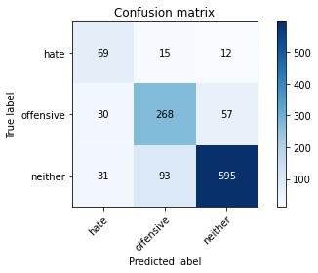

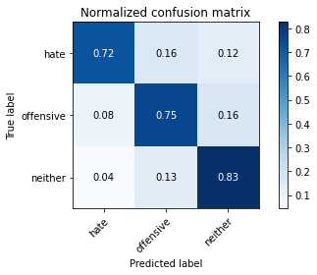

precision recall f1-score support

hate 0.53 0.72 0.61 96

offensive 0.71 0.75 0.73 355

neither 0.90 0.83 0.86 719

accuracy 0.80 1170

macro avg 0.71 0.77 0.73 1170

weighted avg 0.81 0.80 0.80 1170

average eval_loss: 1.02276479583865, accuracy: 0.7965811965811965

training 10 epoch...

46.54737186431885 seconds used......

10 training finished! average train loss: 0.07128658011713877

total clf loss: 4.001848685671575 total adv loss: 3.559428937311168

evaluating...

Confusion matrix, without normalization

[[ 60 24 12]

[ 28 261 66]

[ 34 91 594]]

Normalized confusion matrix

[[0.625 0.25 0.125 ]

[0.07887324 0.73521127 0.18591549]

[0.0472879 0.12656467 0.82614743]]

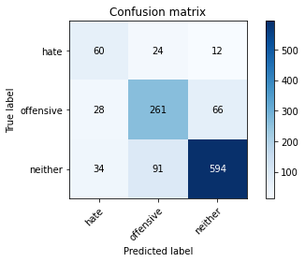

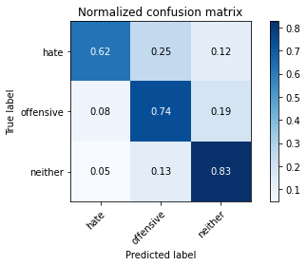

precision recall f1-score support

hate 0.49 0.62 0.55 96

offensive 0.69 0.74 0.71 355

neither 0.88 0.83 0.85 719

accuracy 0.78 1170

macro avg 0.69 0.73 0.71 1170

weighted avg 0.79 0.78 0.79 1170

average eval_loss: 1.0848812938241634, accuracy: 0.782051282051282

5 run......

training 1 epoch...

46.41019248962402 seconds used......

1 training finished! average train loss: 1.910916608113509

total clf loss: 123.21541568636894 total adv loss: 87.44378770887852

evaluating...

Confusion matrix, without normalization

[[ 16 60 20]

[ 5 282 68]

[ 6 100 613]]

Normalized confusion matrix

[[0.16666667 0.625 0.20833333]

[0.01408451 0.7943662 0.1915493 ]

[0.00834492 0.13908206 0.85257302]]

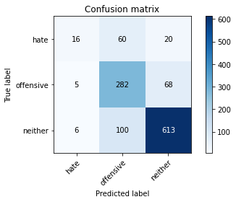

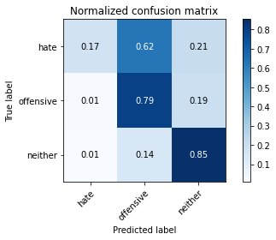

precision recall f1-score support

hate 0.59 0.17 0.26 96

offensive 0.64 0.79 0.71 355

neither 0.87 0.85 0.86 719

accuracy 0.78 1170

macro avg 0.70 0.60 0.61 1170

weighted avg 0.78 0.78 0.77 1170

average eval_loss: 0.5373969855955092, accuracy: 0.7786324786324786

training 2 epoch...

46.26744031906128 seconds used......

2 training finished! average train loss: 1.2334256796882703

total clf loss: 77.535246565938 total adv loss: 57.43957947194576

evaluating...

Confusion matrix, without normalization

[[ 62 22 12]

[ 25 270 60]

[ 32 78 609]]

Normalized confusion matrix

[[0.64583333 0.22916667 0.125 ]

[0.07042254 0.76056338 0.16901408]

[0.04450626 0.10848401 0.84700974]]

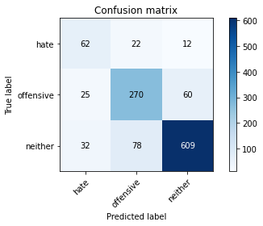

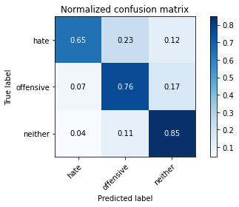

precision recall f1-score support

hate 0.52 0.65 0.58 96

offensive 0.73 0.76 0.74 355

neither 0.89 0.85 0.87 719

accuracy 0.80 1170

macro avg 0.72 0.75 0.73 1170

weighted avg 0.81 0.80 0.81 1170

average eval_loss: 0.5138093662464013, accuracy: 0.8042735042735043

training 3 epoch...

46.59120488166809 seconds used......

3 training finished! average train loss: 0.619082070982609

total clf loss: 41.47238043695688 total adv loss: 27.552211323753

evaluating...

Confusion matrix, without normalization

[[ 39 39 18]

[ 14 293 48]

[ 15 123 581]]

Normalized confusion matrix

[[0.40625 0.40625 0.1875 ]

[0.03943662 0.82535211 0.13521127]

[0.02086231 0.17107093 0.80806676]]

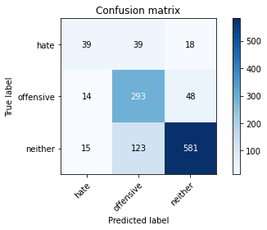

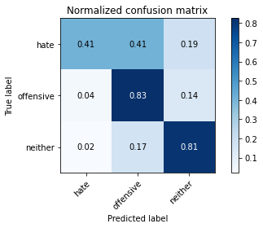

precision recall f1-score support

hate 0.57 0.41 0.48 96

offensive 0.64 0.83 0.72 355

neither 0.90 0.81 0.85 719

accuracy 0.78 1170

macro avg 0.71 0.68 0.68 1170

weighted avg 0.79 0.78 0.78 1170

average eval_loss: 0.6225751594214116, accuracy: 0.7803418803418803

training 4 epoch...

46.33101463317871 seconds used......

4 training finished! average train loss: 0.30633123361099607

total clf loss: 22.802361017093062 total adv loss: 12.492655617534183

evaluating...

Confusion matrix, without normalization

[[ 41 43 12]

[ 11 307 37]

[ 21 137 561]]

Normalized confusion matrix

[[0.42708333 0.44791667 0.125 ]

[0.03098592 0.86478873 0.10422535]

[0.02920723 0.19054242 0.78025035]]

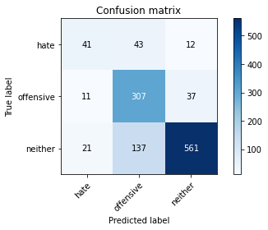

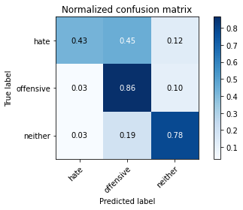

precision recall f1-score support

hate 0.56 0.43 0.49 96

offensive 0.63 0.86 0.73 355

neither 0.92 0.78 0.84 719

accuracy 0.78 1170

macro avg 0.70 0.69 0.69 1170

weighted avg 0.80 0.78 0.78 1170

average eval_loss: 0.8247525747549735, accuracy: 0.7769230769230769

training 5 epoch...

46.36635136604309 seconds used......

5 training finished! average train loss: 0.22606991946052474

total clf loss: 15.940369478892535 total adv loss: 9.663268991280347

evaluating...

Confusion matrix, without normalization

[[ 63 22 11]

[ 36 277 42]

[ 55 106 558]]

Normalized confusion matrix

[[0.65625 0.22916667 0.11458333]

[0.10140845 0.78028169 0.11830986]

[0.07649513 0.14742698 0.77607789]]

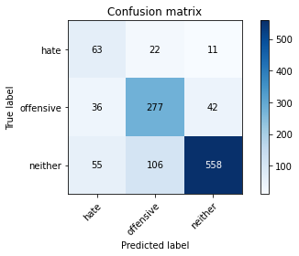

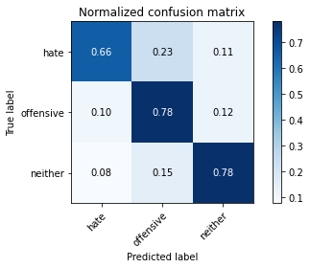

precision recall f1-score support

hate 0.41 0.66 0.50 96

offensive 0.68 0.78 0.73 355

neither 0.91 0.78 0.84 719

accuracy 0.77 1170

macro avg 0.67 0.74 0.69 1170

weighted avg 0.80 0.77 0.78 1170

average eval_loss: 0.7760610404913708, accuracy: 0.7675213675213676

training 6 epoch...

46.55404496192932 seconds used......

6 training finished! average train loss: 0.15854534208893967

total clf loss: 10.57054496370256 total adv loss: 7.081264174776152

evaluating...

Confusion matrix, without normalization

[[ 54 33 9]

[ 29 286 40]

[ 34 124 561]]

Normalized confusion matrix

[[0.5625 0.34375 0.09375 ]

[0.08169014 0.8056338 0.11267606]

[0.0472879 0.17246175 0.78025035]]

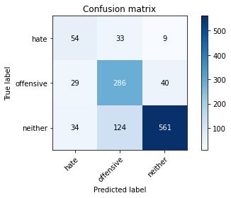

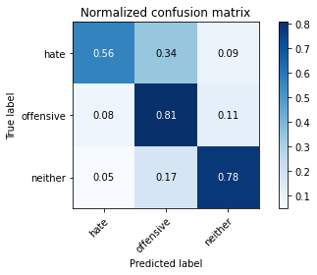

precision recall f1-score support

hate 0.46 0.56 0.51 96

offensive 0.65 0.81 0.72 355

neither 0.92 0.78 0.84 719

accuracy 0.77 1170

macro avg 0.68 0.72 0.69 1170

weighted avg 0.80 0.77 0.78 1170

average eval_loss: 0.861917159567445, accuracy: 0.7700854700854701

training 7 epoch...

46.36601424217224 seconds used......

7 training finished! average train loss: 0.08636477572891192

total clf loss: 6.07960540172644 total adv loss: 3.6966498377369135

evaluating...

Confusion matrix, without normalization

[[ 53 31 12]

[ 20 282 53]

[ 32 96 591]]

Normalized confusion matrix

[[0.55208333 0.32291667 0.125 ]

[0.05633803 0.7943662 0.14929577]

[0.04450626 0.13351878 0.82197497]]

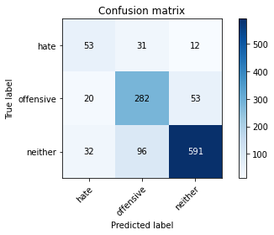

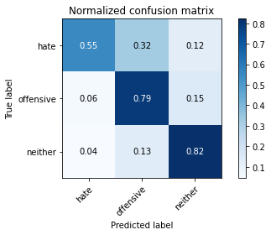

precision recall f1-score support

hate 0.50 0.55 0.53 96

offensive 0.69 0.79 0.74 355

neither 0.90 0.82 0.86 719

accuracy 0.79 1170

macro avg 0.70 0.72 0.71 1170

weighted avg 0.80 0.79 0.80 1170

average eval_loss: 0.8616288906689418, accuracy: 0.7914529914529914

training 8 epoch...

46.23621869087219 seconds used......

8 training finished! average train loss: 0.09747091491664879

total clf loss: 5.680499042966403 total adv loss: 4.762481827950978

evaluating...

Confusion matrix, without normalization

[[ 51 33 12]

[ 13 297 45]

[ 16 119 584]]

Normalized confusion matrix

[[0.53125 0.34375 0.125 ]

[0.03661972 0.83661972 0.12676056]

[0.02225313 0.16550765 0.81223922]]

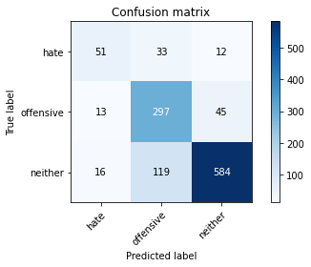

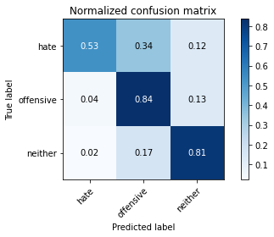

precision recall f1-score support

hate 0.64 0.53 0.58 96

offensive 0.66 0.84 0.74 355

neither 0.91 0.81 0.86 719

accuracy 0.80 1170

macro avg 0.74 0.73 0.73 1170

weighted avg 0.81 0.80 0.80 1170

average eval_loss: 0.9818135321897975, accuracy: 0.7965811965811965

training 9 epoch...

46.12047219276428 seconds used......

9 training finished! average train loss: 0.05758502912104655

total clf loss: 3.211226085200906 total adv loss: 2.8860191975163616

evaluating...

Confusion matrix, without normalization

[[ 49 32 15]

[ 13 303 39]

[ 19 148 552]]

Normalized confusion matrix

[[0.51041667 0.33333333 0.15625 ]

[0.03661972 0.85352113 0.10985915]

[0.02642559 0.20584145 0.76773296]]

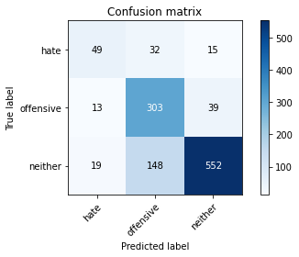

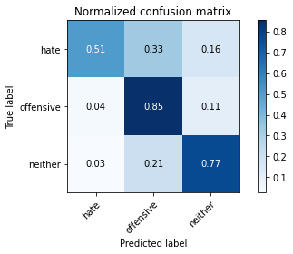

precision recall f1-score support

hate 0.60 0.51 0.55 96

offensive 0.63 0.85 0.72 355

neither 0.91 0.77 0.83 719

accuracy 0.77 1170

macro avg 0.71 0.71 0.70 1170

weighted avg 0.80 0.77 0.78 1170

average eval_loss: 1.0624399507828688, accuracy: 0.7726495726495727

training 10 epoch...

46.145525217056274 seconds used......

10 training finished! average train loss: 0.0934307096811095

total clf loss: 5.038700181234162 total adv loss: 4.768245295097586

evaluating...

Confusion matrix, without normalization

[[ 71 15 10]

[ 51 254 50]

[ 54 92 573]]

Normalized confusion matrix

[[0.73958333 0.15625 0.10416667]

[0.14366197 0.71549296 0.14084507]

[0.07510431 0.12795549 0.79694019]]

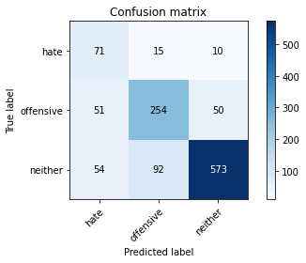

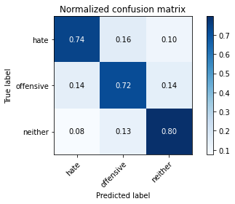

precision recall f1-score support

hate 0.40 0.74 0.52 96

offensive 0.70 0.72 0.71 355

neither 0.91 0.80 0.85 719

accuracy 0.77 1170

macro avg 0.67 0.75 0.69 1170

weighted avg 0.80 0.77 0.78 1170

average eval_loss: 1.0327384612065251, accuracy: 0.7675213675213676